**Lab no:04**

**TO LEARN REPORT GENERATION IN OLTP SYSTEMS**

Generate an OLTP system report which displays the following results:

1. **Total sales in a month** (Use only order table).
2. **Profit/loss in a month** (Use product (to account for purchasing costs), expenditure as well as order tables).
3. **Highest selling product of the month**(By highest sold quantity)
4. **Lowest selling product of the month**(By lowest sold quantity)

**Hint:** Create a report table to hold all the above results from queries after they are executed in the stored procedure and then create a stored procedure in the similar manner as shown above.

Tables:

1. Customers:

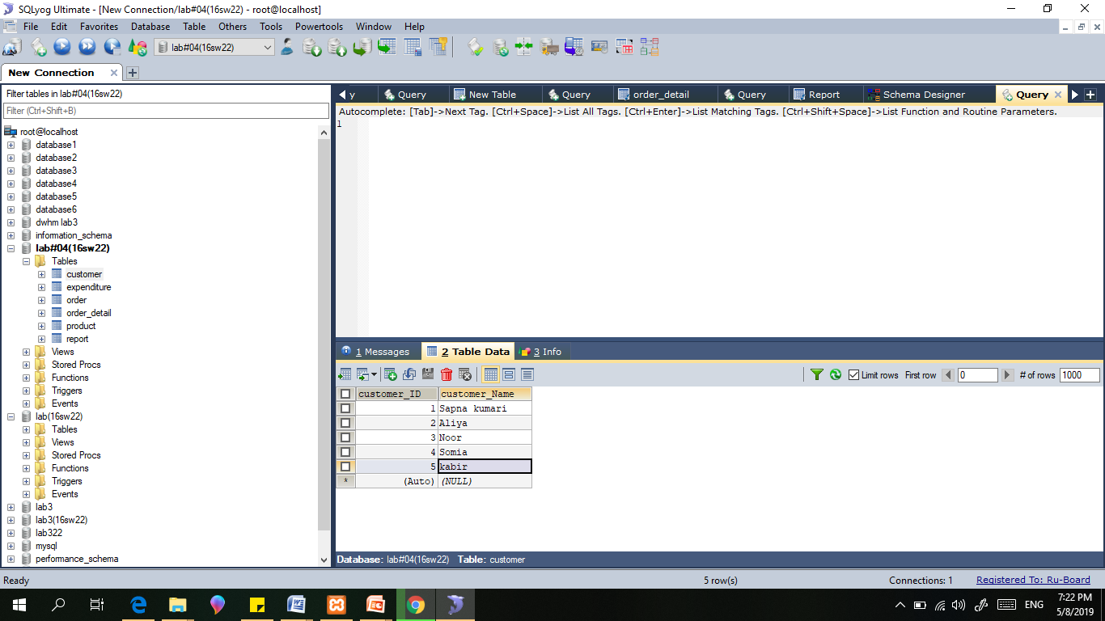

1. Expenditure:

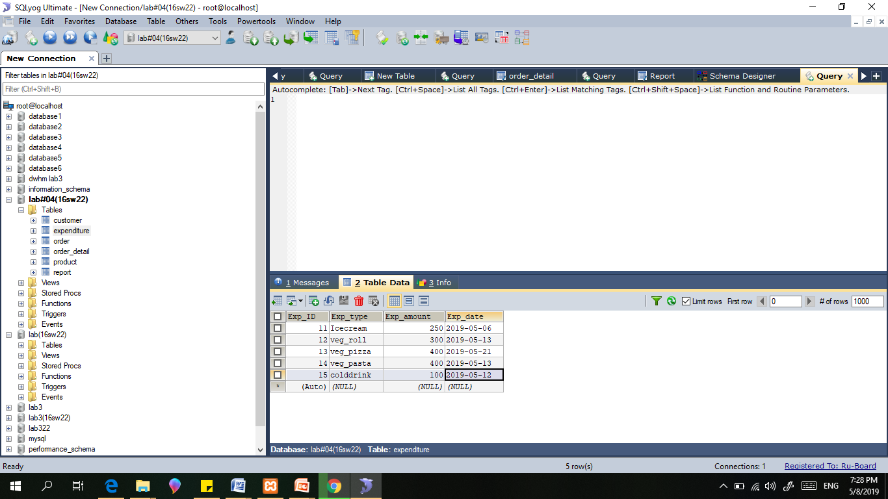

1. Order:

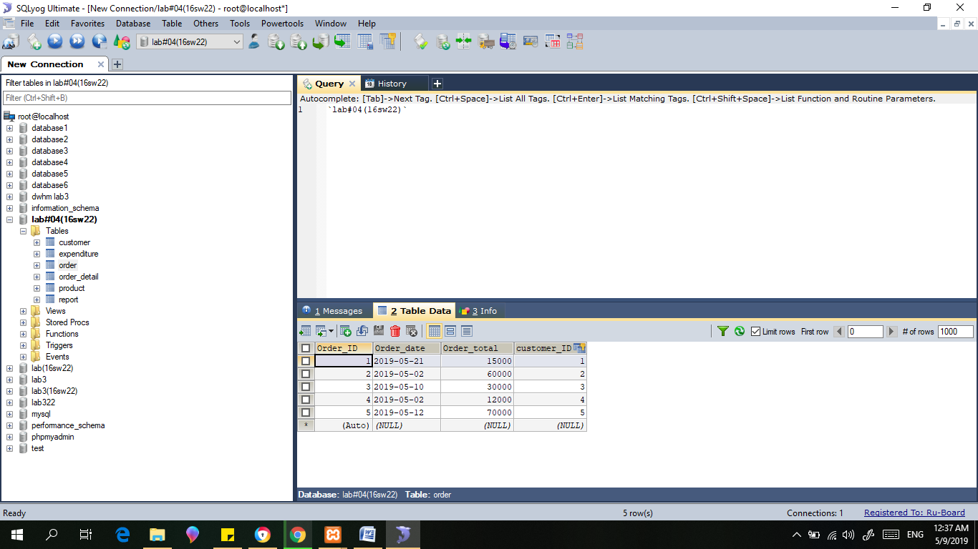

4)Order_Detail:

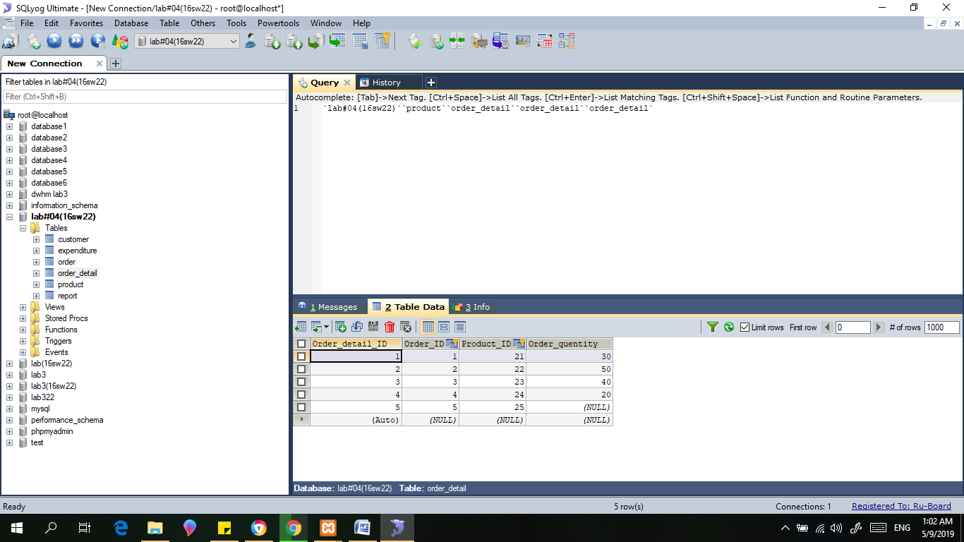

5)product :

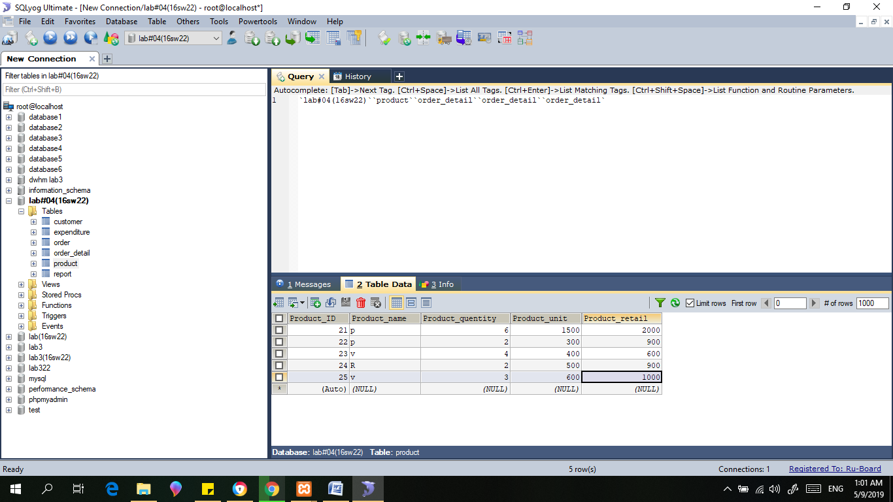

Schema:

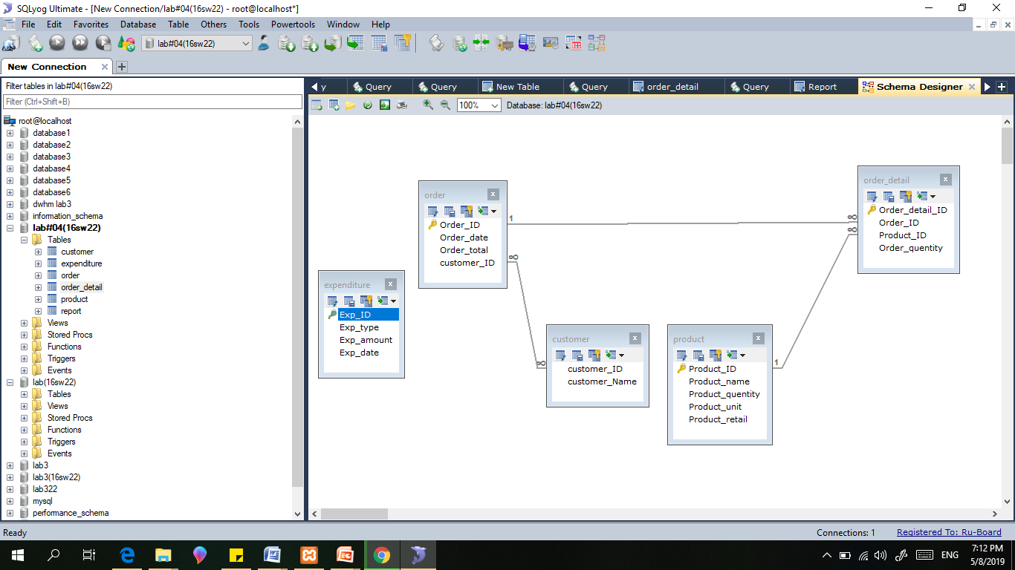

* **Create a Stored procedure with name lab4(16sw166).**

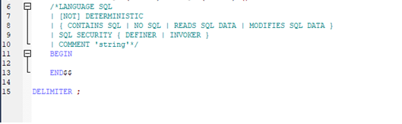

Generate an OLTP system report which displays the following results:

1. **Total sales in a month** (Use only order table).
2. **Profit/loss in a month** (Use product (to account for purchasing costs), expenditure as well as order tables).
3. **Highest selling product of the month**(By highest sold quantity)
4. **Lowest selling product of the month**(By lowest sold quantity)

**Procedure :**

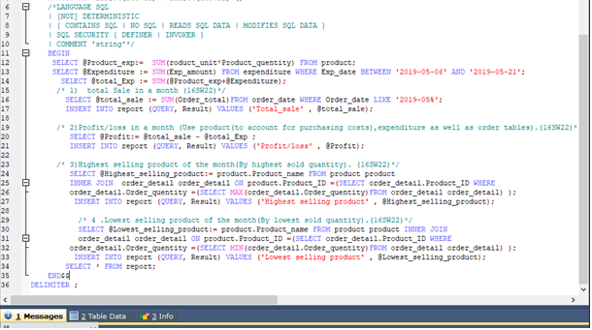

**Execution of Procedure:**

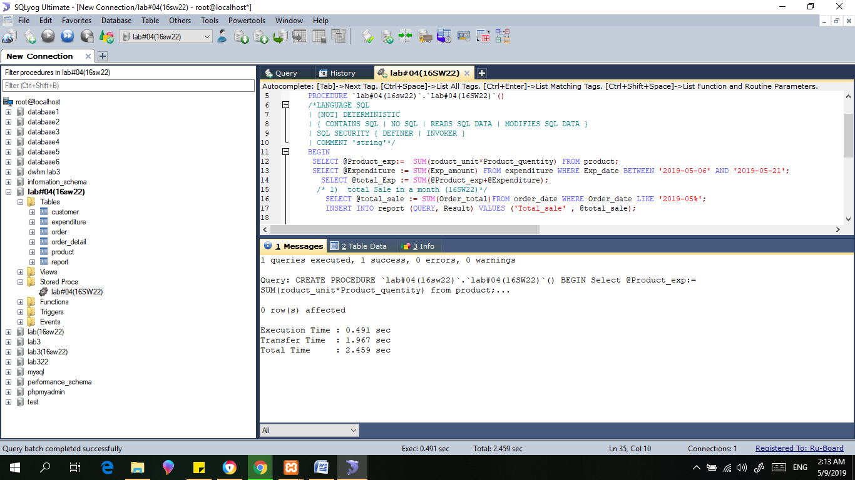

**Result:**

